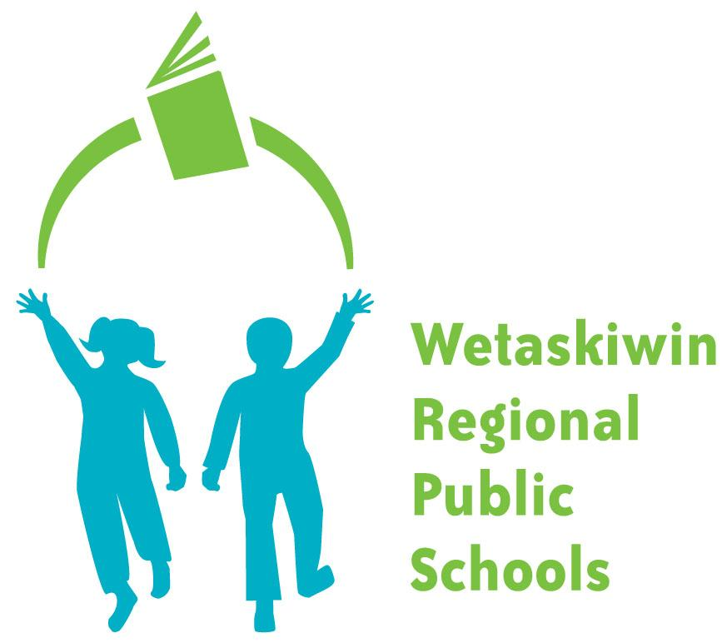

wetaskiwin regional public schools

assessment & reporting handbook

Table of Contents

Section 1: About this Guide --------------------------------------------- 3

Section 2: Current Assessment Initiatives --------------------------- 4

Section 3: Determining Student Achievement ----------------------- 6

Section 4: Grades, Marks and Scales ---------------------------------- 9

Section 5: Communication For Reporting Student Progress --- 11

Section 6: Appendix ------------------------------------------------------- 13

SECTION 1: ABOUT THIS GUIDE

Why is Assessment Important?
In Wetaskiwin Regional Public Schools, we are committed to transforming the learners of today into the leaders of tomorrow. We believe every student can learn and experience success. One of the ways we help all students be successful is by always improving the way we assess and evaluate what students learn. Through careful evaluation of their achievement and growth, we can share information with students, parents and guardians.

This guide will help students, parents/guardians and staff understand:
- assessment
- the responsibilities of staff, students, parents/guardians
- how and when achievement information will be communicated or reported
- how marks and grades are determined
- the steps taken when summative assessments are missing or incomplete

Parents and guardians are the key influences in a student's life. Understanding how a student is achieving in school and how to support that achievement is integral to success in school. Parents and guardians are encouraged to read this guide and contact the school administration if further information is required.

This document follows:
- Education Act
- Guide to Education
- AP 360 Classroom Assessment
- AP 361 Reporting Student Progress

These documents ensure our students learn, are assessed and graded in a similar manner, regardless of which school they attend.

What is Assessment?
Assessment means gathering information about what the student knows, understands and can show the teacher based on the Alberta Programs of Study (curriculum) or their Individualized Program Plan (IPP). Teachers cannot use the students’ behaviour, effort and work habits to decide on their grades, marks or scales unless it is outlined in the Alberta programs of study for a specific subject.

Teachers regularly gather information about students’ learning through a variety of assessment tools. These tools can include observations, conversations, the submission of student work, and tests or quizzes. Through these feedback opportunities, teachers determine students’ areas of strength and the areas in which students may need more time or practice. These assessment activities help teachers shape their lesson plans and allow teachers to give students, parents and guardians a clear and accurate picture of achievement and growth.

SECTION 2: CURRENT ASSESSMENT AND REPORTING INITIATIVES

2021-2024 Three-Year Education Plan

Supporting Student Success

The following groups all have roles to play in supporting and helping students experience success in school as outlined in the Education Act.

Students have a responsibility for their own learning and are expected to:
  - attend school every day and be on time
  - complete assignments, projects and tasks to the best of their ability
  - participate in activities to celebrate learning
  - consistently demonstrate their learning
  - take initiative to revise or redo assignments or tests so they can show growth in their knowledge and skills

Parents and Guardians support the student’s learning by:
- working in partnership with school staff
- providing time and a place for the student to practice and complete assigned work at home
- staying informed about school events through the school’s website, newsletters or other school materials
- keeping in touch with school staff
- regularly accessing student assessment information on the School Powerschool Markbook accessed by parents and students through the Powerschool Parent Portal.
- attending parent-teacher conferences/interviews

Teachers, Educational Assistants and Administration will help the student succeed by:
  - providing appropriate programming for the student
  - clearly explaining what is expected of each student and how the student’s work will be assessed
  - providing multiple opportunities and different ways for students to demonstrate their learning
  - giving students who have missed important assessments and activities the chance to complete the work
  - keeping records describing the student’s successes and challenges
  - keeping an up to date PowerSchool Gradebook
  - providing timely and ongoing communication with you about the student’s progress and achievement
  - providing opportunities for parents/guardians to be involved in the student’s learning

Central Administration Leadership Team guides our division by:
- knowing how schools and students are performing
- knowing that the curriculum is being delivered
- diagnose and provide leadership for system strategies and supports
- set required procedures
- allocation of resources

Board of Trustees:
- the school division is meeting provincial accountability requirements
- set, monitor and review priorities

The Board’s Priorities

SECTION 3: DETERMINING STUDENT ACHIEVEMENT
Classroom Assessment Beliefs
- The instructional decisions that have the greatest impact are made day to day in the classroom
- Teachers must possess and be ready to apply knowledge of sound classroom assessment practices
- Students are crucial instructional decision-makers whose information needs must be met
- Teachers understand that supportive classroom assessment strategies benefit all students
- Teachers use their professional judgement based on the evidence of student learning to determine achievement using the WRPS grade scales.

Types of Assessments
Formative Assessments (Assessment FOR learning)
Throughout the year, the student will work on many activities that help them increase what they know and practice their skills. These activities show the student’s teachers how they are doing, their strengths and where they can improve.

Teachers use this information to adjust their teaching, give the student feedback to help them improve and prepare the student for times when they will receive grades, marks and codes.

Summative Assessments (Assessment OF Learning)
During the school year, the student will have a chance to show what they have learned up to that point in time.

Using their judgment as professionals, teachers make decisions and give grades, marks and codes to the student. They base these decisions on what they’ve seen the student do (observations), discussions they have had with the student (conversations) and the work the student has completed (products).

(Assessment AS Learning)
Assessment as Learning is the use of ongoing self-assessment by students in order to monitor their own learning, which is “characterized by students reflecting on their own learning and making adjustments so that they achieve deeper understanding.” (Western and Northern Canadian Protocol for Collaboration in Education [WNCP], 2006, p.41)

Planning
Teachers are required to plan instructional strategies to move student learning forward. Planning can come in a variety of forms and follow Alberta education documents including:
- TQS
- AP 436
- Program of studies
- Math Prioritized Outcomes
- Math Scope and Sequence
- Literacy Prioritized Outcomes

An easy tool for parents is the My Child’s Learning: A Parent Resource (Curriculum at a Glance) on the Alberta Education website.

Student Work

Missing or Incomplete Student Work
When the student has missing or incomplete work, we will:
  - meet with the student to discuss a plan to complete the work
  - provide reasonable supports for the work to be completed and submitted. This might include: extra time, provision of school time to complete the work and/or provision of teacher assistance
  - provide reasonable task adaptation/modification if needed
  - if continued concerns regarding homework completion/submission occur, parents will be notified through notes in the student agendas, phone calls and/or emails

Division Belief and School-Based Rewrite Policy
WRPS believes that students should have the opportunity to improve their academic performance. These opportunities and adaptations will be provided through each school’s process.

Academic Integrity
All students are expected to conduct themselves with academic integrity. A student who is:
- diligent in their studies,
- properly reference work developed by others that they use in assignments and
- displaying respect for others and themselves
are characteristics, but not inclusive, of a student showing academic integrity.

Standardized Testing
Alberta Education mandates that Provincial Achievement Tests and Diploma Exams be administered each school year. Results from these assessments provide schools, school authorities and the province information about student learning and achievement to monitor and improve student learning.

The Provincial Achievement Tests (PATs)
PATs measure student learning based on grade-level outcomes prescribed in the curriculum. Students in Grades 6 and 9 in English or French language arts, math, science and social studies are expected to take the PATs. Aggregated results are shared publicly to show how Alberta students are doing, compared to provincial standards. We will report individual results to students and parents/guardians in a statement in the June progress report. While PATs are an important part of determining student growth and achievement, they are just one part of the assessment process.

Diploma Examinations:
Diploma Examinations have three main purposes:

- to certify the level of individual student achievement in the selected 30-level courses;
- to ensure that province-wide standards of achievement are maintained; and
- to report individual and group results

The program has diploma exams in selected 30-level courses: Biology 30, Chemistry 30, English Language Arts 30–1, English Language Arts 30–2, Français 30–1, French Language Arts 30–1, Mathematics 30–1, Mathematics 30–2, Physics 30, Science 30, Social Studies 30–1, and Social Studies 30–2.

To receive a high school diploma, students are required to write at least two diploma exams, either English Language Arts 30–1 or English Language Arts 30–2 and either Social Studies 30–1 or Social Studies 30–2.

Alberta Education High School Completion

Formative Assessment Tools
To support instruction, schools will be using some of the following formative assessment tools, where age-appropriate:
- Fountas and Pinnell Reading Assessment and Intervention Programs
- Star Reading Assessment
- Reading Readiness
- The Math Intervention/Programming Instrument (MIPI)
- English as a Second Language (ESL) Proficiency Assessments
- Highest Level of Achievement Test (HLAT)
- Schonell
- Words Their Way Spelling Inventory

Common Assessments
- WRPS Math Common Assessments

SECTION 4: GRADES, MARKS and SCALES
To decide on the student’s grade, mark or code at the end of a reporting period, teachers use evidence of what your child has learned and their professional judgement

Guidelines for Reporting
Summative Reporting will not include:
- Class Averages: students progress is independent of their peers and class averages will not be reported
- Effort/Behaviour: Student’s reported learning is about the learning outcome. ‘behaviour factors’ (effort, participation, etc) will not have an impact on a grade reflecting academic achievement; unless they are specifically set out in the program of studies as a learning outcome
- Group Work Marking: Each student is individually accountable for their learning. A group project or group assessment strategies will only be added to a student’s mark when the group project is intended to develop ‘role skills’ or the course of study sets group skills as an outcome of the learning.
- Late: Student’s achievement relative to the learning outcome is the basis for grading. Work submitted late will not be graded downward and then factored into the final grade. Support mechanisms or pyramids of intervention must be in place within the school site to address the concern/issue.
- Zeros: Assessment of students utilizing zeros is not a true reflection of student learning. The Division discourages the utilization of zeros in assessment but recognizes that they might need to be used as a part of the evaluation process.
- Homework is meant to:
  - help support the student’s learning
  - reinforce what the student has learned in school
  - give the student more practice
  - completion of class assigned work
  - prepare for upcoming learning
- Bonus Marks: bonus marks are not appropriate when assessing learning outcomes but other learning opportunities should be provided to improve a mark

How we are Going to Use Assessments
It is important to provide frequent, descriptive and prescriptive feedback to students, based on the learner outcomes.

Formative Assessments (Assessment for Learning)
- students are assessed based on the learner outcomes as stated in the programs of study (including locally developed courses and electives designed at individual school sites)
- student grades are compiled about how each student is progressing toward mastery of the learning outcomes
- learning is developmental; therefore, it is most appropriate to emphasize the most recent stage of achievement when reporting student level of learning/mastery of the learning outcome
- it is not appropriate for formative assessment information, which is used by students and teachers to inform teaching/learning strategies, to be factored into the final report or grade

Summative Assessments (Assessment of Learning)
- teachers plan directly from the Program of Studies, and therefore can articulate in advance of teaching, which learner outcomes their students are to achieve and what will be accepted as evidence of their achievement
- students must clearly understand the learner outcomes they seek to achieve, and that they understand what will be accepted as evidence of their achievement (assessment criteria). Students should be actively involved in the feedback process
- teachers understand and utilize the relationship between assessment and student motivation; therefore teachers have a responsibility to build assessments that enhance learning
- teachers continually use classroom assessment information to revise instruction

Best Practices Using PowerSchool Gradebooks
Schools may have additional expectations for communicating student learning specific to each site. Below are general practices that support ongoing assessment being effectively communicated through PowerSchool and PowerTeacher Pro.
- A minimum of 3 and a maximum of 10 summative assessments will be used each reporting term per subject
- Updated Powerschool every 10 operational days provided there are assessments to input during that period. These updates would include the input of marks and may include comments for assessments.
- Assessed and returned assignments will be reported a maximum of 10 instructional days.
- Usually, assignments will be assessed within 5 operational days of submission. Larger, more complex assignments will take longer to assess and will take longer to return.
- Formative assessment will be used to inform instruction and may be recorded in the teacher’s grade book, but will not be used in the calculation of a grade.

Reporting Using Grade Scales

Why Grade Scales Are Used
Scales provide students, parents/guardians and teachers a cumulative description of how a student is doing based on the learning outcomes.

Grade Scale
On the student’s progress report, a teacher may use these codes for reporting grades/marks.
Student achievement is reported using the following scale: Current Grade Scale descriptions

Grade Level of Achievement (GLA)
GLA shows the current grade level at which a student is being taught. This is usually the same grade in which a student is enrolled. GLA appears on each progress report for English and French language arts and math.

SECTION 5: COMMUNICATION FOR REPORTING STUDENT PROGRESS
There are many ways we report student’s learning throughout the year. We encourage parents/guardians to review the student’s reports and attend conferences regularly. Understanding how a student is achieving in school and how to support that achievement is integral to success in a school.

Reporting
- Academic achievement (summative assessment) shall be reported separately from the academic growth and the behavioural characteristics that impact learning.
- Our reporting mechanisms provide feedback to stakeholders on all three elements of learning. PowerSchool will be the primary form of communicating student learning. Reporting mechanisms may be in the form of, but not limited to, digital reporting through PowerSchool, report cards, progress reports, portfolios, parent-teacher interviews and student-led conferences.
    - The ‘academic growth’ element shall reflect how the student has progressed relative to their initial understanding of the outcome, and/or their ability to perform any skills inherent in the outcome. We will inform stakeholders about the degree of progress a student has made, even if they have not fully accomplished the outcome. This information will be provided in a ‘comments box’ on the report card, in the student’s growth portfolio, in communication with the parent; or whatever form is most appropriate to the school site and the individual student.
    - The ‘Learner Attributes’ element shall reflect the students’ work habits relating to achieving the learning outcomes. Areas like attendance, completion of assignments, listening skills, level of effort, etc. are important in each student’s mastery of the outcome but are more appropriately separated from the students’ academic achievement grade.
    - The ‘symbolic representation’ of student learning relative to the outcome is less important than the process by which it was determined. Therefore percentages, letter grades or rubric derivations are all acceptable methods of reporting if the process by which they were determined was outcomes-based and capable of showing student progress towards mastery.
- Students receiving adapted programming (on the graded program of studies) or modified programming (on the graded program of studies) shall have that reflected within the reporting mechanism.

Our Communication Plan for Reporting Progress
- Division I and II are under summative grade scale of assessment reporting
- Division III is under summative percentage assessment reporting for core subjects and will use a summative grade scale of assessment reporting for non-core courses
- Division IV is under summative percentage assessment reporting

Reporting Period Dates - 2021/2022
- Quarter I - September 1 - November 7
- Quarter II - November 8 - January 31
- Quarter III - February 1 - April 14
- Quarter IV - April 15 – June 15 (modified) or June 28 (regular)

Teachers will comment on student learning in each subject area in each reporting term.

Individualized Program Plans (IPPs)
IPPs for students who need specialized services and support, the IPP is a working document that is developed within the first reporting period of the school year. It is a record of the student’s progress related to specific goals and strategies. It gives confirmation that a student’s needs are being addressed and provides information about accommodations and supports the student’s needs to succeed. The IPP is reviewed at least three times a year. We expect all stakeholders involved to provide input into the IPP.

Individual Schools IPP Procedures (dates)
To be reviewed and completed by the last school day of September and at the end of the year by the last day of classes. The plans will be reviewed at the end of each quarterly reporting period in November, January, April and June. These plans are fluid documents that can change throughout the school year to support the needs of the student.

Reference Material:
AP 214
Alberta Education Inclusive Education
Standards for Special Education

SECTION 6: APPENDIX
Definitions used within Wetaskiwin Regional Public Schools: Using language consistently and effectively will allow a shared understanding of assessment and grading, and inform our educational practice in the interests of higher levels of student learning. Provided below are definitions used about assessment/reporting throughout WRPS.

GLOSSARY OF RELEVANT TERMS:
accommodation: A change or alteration in the regular way a student is expected to learn, complete assignments or participate in classroom activities.

achievement level: A student’s demonstration of knowledge, skills and attitudes relative to grade-level learner outcomes.

adapted programming: Programming that retains the learning outcomes of the program of studies and where adjustments to the instructional process are provided to address the special education needs of the student.

assessment: Process of collecting information on student achievement and performance that includes a variety of assessment tasks designed to monitor and improve student learning.

assessment for learning: Ongoing exchange of information between students and teachers about student progress toward clearly specified learning goals. (also called formative assessment) Formative assessment: assessments that take place during instruction and learning to:
• inform students, on an ongoing basis, about their progress towards achieving the intended learning outcomes as set out in the programs of study.
• identify the gains and difficulties students are experiencing in what they are being asked to learn or perform.
• provide specific, descriptive, and meaningful feedback.
• motivate students to learn by providing feedback continuously. Wetaskiwin Regional Public Schools Administrative Procedures
• monitor student performance toward the expected learning outcomes as set out in the programs of study and adjust instruction based on the findings where necessary.

assessment of learning: Assessment experiences designed to collect information about learning to make judgments about student achievement and performance at the end of a period of instruction that can be shared with those outside the classroom. (also called summative assessment) Summative assessment: assessments that take place after an instructional segment (e.g., group of integrated lessons, unit, reporting period, grade) to:
• describe the degree to which each student has achieved the learning outcomes as set out in the programs of study.
• analyze assessment information and results obtained from assessments conducted for each instructional segment to understand each student’s progress and achievement at the end of the instructional segment and to inform future instructional planning.
• synthesize assessment information and results obtained from assessments conducted for each instructional segment for the reporting period to form comments and grades, which summarize the student’s strengths and areas of need, and be communicated to students and their parents/guardians at the end of the reporting period.
• evaluate the effectiveness of the instruction used during the reporting period.

enrichment: Providing more in-depth learning opportunities with respect to the learner outcomes at or above the enrolled grade level.

grade level of achievement: A teacher judgment, based on the results from a variety of classroom assessments throughout the school year, expressed as ‘at, above or below’ relating to learner outcomes in a subject area after a course for a specific grade level has been completed at the student’s enrolled grade.

learner outcomes: What Alberta Education expects a student to learn; the knowledge, skills and attitudes a student demonstrates as a result of schooling.

modified programming: Programming in which the learner outcomes are significantly different from the programs of study and are specifically selected to meet students’ special education needs.

Other Links
AP 360 Classroom Assessment
AP 361 Reporting Student Progress
AAC visual https://www.aac.ab.ca/updated-aac-key-visual
WRPS Prioritized Outcomes
Curricular Exemplars https://www.learnalberta.ca/content/mychildslearning

